KCSE 2024 COMPUTER STUDIES PROJECT
KAKAMEGA SCHOOL
UZIMA BOREHOLE DRILLING SYSTEM
Aloo Andrews Oduor
7/7/2024

DECLARATION
I declare this being the full system of Uzima Borehole Drilling System which I have computerized for Uzima Borehole Drilling Company so as to enable the smooth running of the company by fastening the processes engaged in the company so as to maximize on profits to be attained by the company. I have managed to create the system under the guidance of my Computer Studies teacher, Madam Agnes Adipo, for the seven months provided by the Kenya National Examinations Council-KNEC.
By: ALOO ANDREWS ODUOR

ACKNOWLEDGEMENT
This is to appreciate all those who helped in the designing of the Uzima Borehole Drilling System by any way either motivating me, providing finance for the requirements of developing the system or helping me with ideas of adjusting the ones I initially had.
This includes members like:
- Mr. Idd Barassa- Teacher.
- Madama Agnes Adipo- Teacher.
- Brian Noah- brother
- Dr Julius Mambili – The Chief Principal Kakamega School

TABLE OF CONTENTS
-CHAPTER ONE 2
1.0 SYSTEM ANALYSIS 2
1.1 INTRODUCTION 2
1.2 PROBLEM ANALYSIS 2
LIMITATIONS 3
1.3.2 SYSTEM STRUCTURE 3
1.4 PROPOSED SYSTEM 4
1.4.1 OBJECTIVES 4
1.4.2 THE SCOPE OF THE SYSTEM 4
1.4.3 BENEFITS OF THE SYSTEM 4
1.4.4 FEASSIBILITY 5
TECHNICAL FEASIBILTY 5
SCHEDULE FEASIBILITY 5
OPERATIONAL FEASIBILITY 5
ECONOMIC FEASIBILITY 5
1.5 DATA GATHERING 6
1.5.1 INTERVIEWS 7
1.5.2 QUESTINNAIRES 8
1.5.3 DOCUMENT REVIEW 9
1.6 REQUIREMNTS SPECIFICATIONS 9
INPUT SPECIFICATINS 9
HARDWARE SPECIFICATIONS 9
SOFTWARE SPECIFICATIONS 9
STORAGE DEVICE SPECIFICATION 10
OUTPUT SPECIFICATIONS 10

Summary

UZIMA BOREHOLE DRLLING SYSTEM
Uzima company is one of the leading borehole service providers in Kenya. They provide borehole drilling services to industrial, commercial and domestic clients
The company offers either symmetric drilling, or core drilling, or geo-technical drilling. After the drilling, they install a water pump. Water pumps are of various types such as submersible electric pumps, solar pumps and hand pumps. The pumps are charged according to: the depth of the borehole, height of the tank above the ground and the type of pump. They also install tanks and charge depending on the capacity of the tank in litres. The company also offers other services such as plumbing and pump maintenance. The plumbing services are charged according to the type of pipes, diameter of the pipes in inches, length of the pipes and the number of outlets.
Clients who are interested in these services are required to apply. The company then records their details which include: Name, address, telephone number and details of the intended bore-hole location among other details. Each client is required to pay survey fees and local authority fees as shown in Table 1.
Table 1: Survey and local authority fees
Client Category | Survey Fees | Local Authority Fees
Industrial  Commercial  Domestic | 20,000  15,000  7,000 | 50,000  30,000  10,000

Other services are charged based on the rates in Table 2, Table 3, Table 4.
Table 2: Drilling Services
Type of Drilling | Down Payment Fee
Symmetric drilling | 130,000
Core drilling | 225,000
Geo-Technical Drilling | 335,000

Table 3: Pump Installation
Type of pump | Cost
Submersible electric pump | 90,000
Solar pump | 65,000
Hand pump | 30,000

Table 4: Depth and Height in Meters
Depth and Height | Cost per Meter
1-100 | 1500
101-200 | 1500
201-300 | 2000
Over 300 | 2500

Every client is charged 16% tax on the total cost of the service offered.

CHAPTER ONE

1.0 SYSTEM ANALYSIS

1.1 INTRODUCTION
Uzima Company is an organization that deals with drilling of boreholes, installation of pumps, plumbing services and maintenance for the pumps. The drilling of boreholes is categorized into Symmetric, core, and also Geo-Technical drilling. The various types of pumps they install after drilling include Hand pumps, Solar pumps and also Submersible electric pumps. The charges are determined by the type of pump, depth of the borehole and the maximum height of the tank above the ground. They offer their services to clients upon appliance. The company offers services categorically to Industrial, Commercial and Domestic clients. The company charges its clients basing on a number of criteria. For instance, the company charges an industrial client KSh 20000 for survey and a local authority fee of KSh 50000. A commercial client is entitled to KSh 15000 and KSh 30000 for survey and local authority fees respectively. A domestic client pays KSh 7000 and KSh 1000 for survey and local authority fees respectively. For those clients who prefer Symmetric drilling, they have to pay a down payment of KSh 130 000. Core drilling costs KSh 225 000 and Geo-Technical costs Ksh 335 000. The installation of pumps follows suite after drilling. A submersible pump costs KSh 90 000, a solar pump costs KSh 65 000 and finally a Hand pump costs KSh 30 000 only. The depth and height in metres of the drilled borehole are considered and charged as per the range. A depth of up to 100m is charged at KSh 1000 per metre . Ranging from 101m to 200m, it costs KSh 1500 per metre. From 201m to 300m, a client pays KSh 2000 per metre. A fixed charge of KSh 2500 is payable for a depth of more than 300m. On the total cost of the services offered, a client is by default charged a tax of 16% to the total amount.

1.2 PROBLEM ANALYSIS
The problem at hand is to develop a computerized database management information system that would compute, process, store and retrieve data in the Uzima Borehole Drilling System and the company as a whole. Currently, Uzima Company uses a manual data handling, processing, and storage techniques. The rapid growth of clients number applying for their services has resulted in inefficiency and poor management leading to inaccuracy which result to disappointment and dissatisfaction within the company. Massive, clients data, loss and inaccurate calculations due to unreliable manual data processing has therefore necessitated the development of this computerize system. This would reduce on employees complains about Salary payment being late and less and also frequent retrenchment of bursars due to accounting mistrust. 1.3 OVERVIEW Uzima Company implies use of non-scientific calculators to satisfy all calculations and computations. To produce various transactions on revenue and tax in the company all transaction details have to be summarized on a single sheet before surrender to the Company’s General Manager. During service delivery t clients, he/she is prompted to duely fill in the forms and at the moment make transactions manually to the bursar. Once a task is cleared, the bursar accounts for the revenue and piles the transaction details in spring files. In this system, physical interaction with the client s vivid at every stage of registration and clearing. All the amounts are safely kept in drawers in the bursar’s office and accounts ledgers updated. After every seven days, the bursar gives a report on the revenue earned and the respective totals on every service offered. This is first achieved by grouping all incoming transaction records in one sheet, manually adding the values and summarizing the totals in manually constructed tables then filled.

LIMITATIONS
The current Uzima Company System has a number of limitations which include:
- High risk of data loss during processing or upon storage in record books, this leads to massive loss of sensitive clients data and other organizational transaction details.
- High travel cost for the registration personnel who manually collect required clients’ details and distribute print outs to clients.
- The type of storage medium i.e. Ledger books and spring files; used is expensive to purchase and maintain their condition.
- The high cost of employing more personnel to reach out for the large numbers limits the company from investing in other parts of the business.
- More chances for unnecessary duplication of data causing confusions and dissatisfaction during transaction and thus resulting into inconveniences.

1.3.2 SYSTEM STRUCTURE
Uzima Company currently uses a manual method for data entry, calculations and manual working out of totals, paid tax and calculations of total revenue. The manual data processing cycle prompts for manual output which are in form of written receipts. The data entry phase is ensured by filling the forms which have Name, Address, Email Address, Telephone Number Client Category and the details of the desired borehole location fields. The forms are collectively used to manually update the records ledgers. Fees paid are added to the Accounts record books. All transaction details are handled by the bursar. During a drilling service, the drilling, plumbing and pump equipment are transported from the stores where their records are maintained in ledgers. This is ensured by crossing over the unstuck items. The down payment fees are recorded and handed over to the bursar before service delivery. The driller is transported a day earlier to the area of site. Machine operators are accompanied by their respective remedy engineers who at the moment work on ay breakdown. Immediately after the drilling, the services applied for are at the moment satisfied and the task added to the completed tasks record books. This is coordinated by the secretary. The casuals are paid and the rest of the amounts handed over to the bursar for accounting. This system is made up of structural administration, therefore wholly manual.

1.4 PROPOSED SYSTEM
The alternative for the Manual Uzima Company System is a computerized database Management System with a series of automated electronic database management software this case MS Access and Microsoft Word as the electronic word processor. The Database Management System is meant to efficiently store, accurately process and satisfactorily output data and information with ultimate ease. Related tables, calculation queries and information reports for part of this Database Schema.

1.4.1 OBJECTIVES
- To accurately and efficiently compute tax paid by each client.
- To efficiently and error-freely compute total revenue generated by the company from each service with high degree of accuracy
- To follow up with the company’s progress in a summarized way.
- To increase the speed of input into the organization.
- To increase the lifespan of data kept.
- To reduce the rate at which data is incorrectly entered into the system.
- To reduce the high cost of buying the bulky materials to store information.

1.4.2 THE SCOPE OF THE SYSTEM
The alternative Computerized Database Management System is meant to improve accuracy, efficiency and ease of use in the data processing cycle of this company. The proposed system will be able to accurately input new clients’ records ,services offered ,register new items process totals for every client serviced clients, accurately and scientifically work out total amount charged on plumbing , survey and local authority fees and total revenue generated by the company. The proposed system also generates reports readily on demand in a very user friendly format that can be easily interpreted upon retrieval or printing. The database is regularly updated and frequent backing up of data is ensured to minimize on risks of data loss due to unauthorized compromised.

1.4.3 BENEFITS OF THE SYSTEM
- The Database Management Information System is to occupy a smaller memory of the storage space.
- Reduced system running and maintenance cost since there is reduced number of registration and accounting personnel.
- Accurate computation of all amounts and tax paid by each client.
- Efficient registration and maintenance of clients’ applications for services and ensured no duplication.
- Accurate computation of revenue generated by the organization from each service from all clients.
- The system offers a large electronic storage sheet for more clients with less capacity of the memory used.

1.4.4 FEASSIBILITY
As the system analyst of the proposed Uzima Company Database Management System, I have carried adequate research and established a comprehensive study to prove the benefits of the proposed system against the drawbacks of the current manual Uzima Company System. The reports below vividly show the findings;

TECHNICAL FEASIBILTY
The proposed computerized system has high recommendation of computerized environment in addition to the trained personnel required.
Hardware specifications include:
- A computer with 8GB RAMS, 256 GB HDD space, corei7, POS terminal equipment and a Wi-Fi Router.
- Software requirements include:
- Windows 10/11 OS, Ms Access 2019,Ms word 2019, Latest Antivirus and Google Chrome.
Trained personnel such as Network Administrators, Electronics Technicians, Data analyst, and a System Analyst are on demand.

SCHEDULE FEASIBILITY
For this newly developed system, the development and testing phase took a maximum of 7 months. The new system needed a quick changeover strategy which necessitated the long period. The problem recognition and system analysis both took a maximum of a month each. System design and construction took 3 months. One month was enough for the implementation and testing whereas the remaining on month was allocated for System review and maintenance.

OPERATIONAL FEASIBILITY
The new system is likely to change the company’s environment because some employees are required to be trained on the new system so as to run it efficiently. The organization noted down that the system should be a user friendly interface. For the system to be fully operational and functional, all specified hardware , software and gray ware requirements are to be adequately availed, assembled and implemented.

ECONOMIC FEASIBILITY
This report is to fully ascertain that this proposed system is economically viable and efficient for use in Uzima Company. The summarized report is as tabulated below:

ITEM(S) | YEAR 1 | YEAR 2 | YEAR 3
COST(KSh)
Development | 400000 | 0 | 0
Infrastructure | 200000 | 100000 | 50000
Maintenance | 0 | 80000 | 100000
TOTAL EXPENDITURE | 600000 | 180000 | 150000
Transport | 200000 | 250000 | 300000
Labour | 500000 | 550000 | 600000
Raw materials | 500000 | 800000 | 920000
TOTAL EXPENDITURE | 1200000 | 1600000 | 1820000
TOTAL BENEFITS | 600000 | 1420000 | 1670000

Vividly with idealistic examination of the economic report, the proposed system is strongly economical upon implementation. The projected profits advocate for changeover from the current system to a computerized one.

1.5 DATA GATHERING
Uzima Company gave a prompt to start developing the system. After signing for the contract, the next step was to discover the drawbacks and develop a new system whose requirements and other information was based on fact finding using:
- Questionnaires
- Interviews
- Document review
- Observation

1.5.1 INTERVIEWS
The method was preferably used as it involved one on one questioning of the current system administrators about operation of the current system and the background information adequately used in coming up with the Computerized Uzima Company System. The sample is as show below:
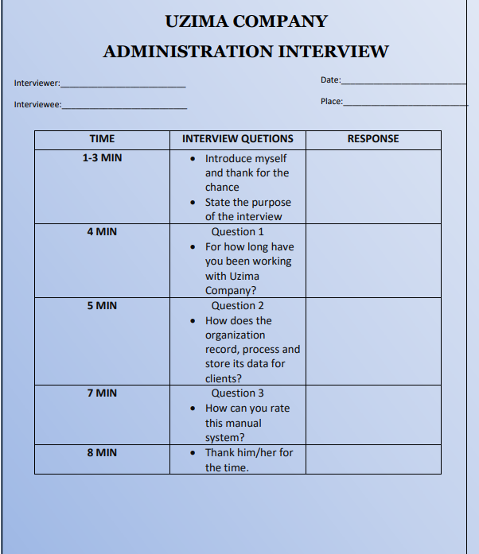

1.5.2 QUESTINNAIRES
A structured questionnaire was used to gather related information from the employees of Uzima Company and the casual team. The sample is as shown below;
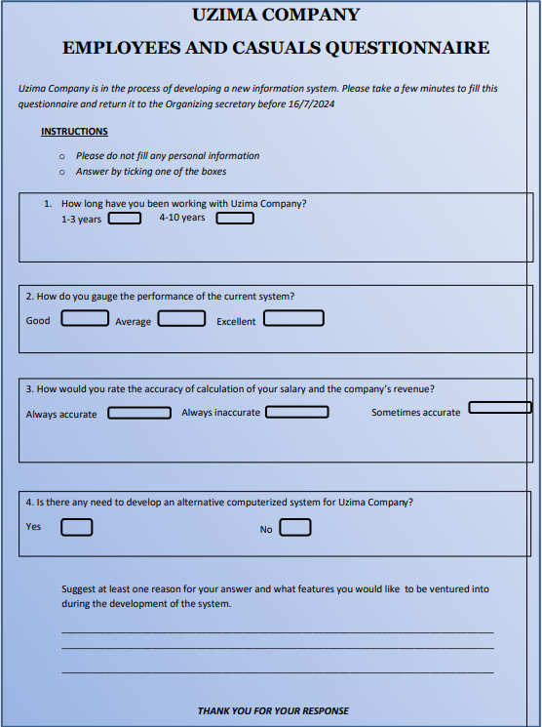

1.5.3 DOCUMENT REVIEW
This method involved going through the documents used with the current manual Uzima Company system, scrutinizing various documents which include:
- Receipts of employees transactions
- Employees pay slips
- Statements of services offered
- Ledgers books
It was reported that there was a lot of redundancy in data administration.

1.6 REQUIREMNTS SPECIFICATIONS
In order to address concerns and loss of implications of switching from the current manual system to an automated system, a number of functional requirements are necessitated in this specifications.
The criteria used heavily considered user-friendliness, initial and maintenance cost, operation efficiency also put in place.

INPUT SPECIFICATINS
At the registration of clients who have applied for Uzima Company services, their Name, Address, Telephone Number, email, Client category and details of the location of the borehole captured. Registration fees which include Survey and Local Authority fee, Drilling Services fees, Pump Installation and Down Payment for the drilling are also captured. Upon delivery of items by suppliers, their details such as Name, Serial Number ,Buying price are captured.

HARDWARE SPECIFICATIONS
For the Uzima Company Computerized environment, the use of latest technology can only be ignored at the company’s peril. At least 15 Desktop computers each with architecture as follows; 526+ GB HDD space,8GB+ RAM,64-bit, Intel corei7 are needed. A maximum of 5 Epson printers, 3 scanners, 30 Ethernet cables, a switch, 2 Wi-Fi routers and a 1TB external HDD. A UPS of about 570W is also essential. POS terminal equipment are also part of the hardware requirements.

SOFTWARE SPECIFICATIONS
This computerized environment-based system is to run under a number of programs. The main program to be installed in each computer is the Windows 10 or Windows 11 OS and accompanied by MS Office Suite. Database management Softwares such as MS Access 2019 or SQLite can also be installed. Microsoft Edge or Google Chrome can also be used as a web server for browsing for the mail clients such as Microsoft Outlook which enhances communication.

STORAGE DEVICE SPECIFICATION
Due to frequent and regular reports generation, there is need for storage of records for the sake of reference and ease of retrieval on demand. This brings about the necessity for a safe storage technique for the processed information. A 526+GB HDD and an Online Backup Center such as Google Drive or iCloud is recommended. Another physical medium for backup is necessary, in this case a 256GB External HDD.

OUTPUT SPECIFICATIONS
The main interest of an information system is the output. For this proposed Uzima Company Database Management System, the high quality and standard format of information is emphasizing. This is ensured through user—friendly interface and accurate background database processes to come up a number of reports: Tax charged reports; Revenue generated reports, Total fee reports, Clients registration reports and Total Individual payment reports. The reports are electronically generated and thus high accuracy levels. The physical printouts are made available by use of EPSON printers.

CHAPTER TWO

2.1 System Design

2.1.1 System Flowchart

In this section, The Uzima Company computerized system is depicted logically using a flowchart which closely shows the procedural steps of each and every module in the system.
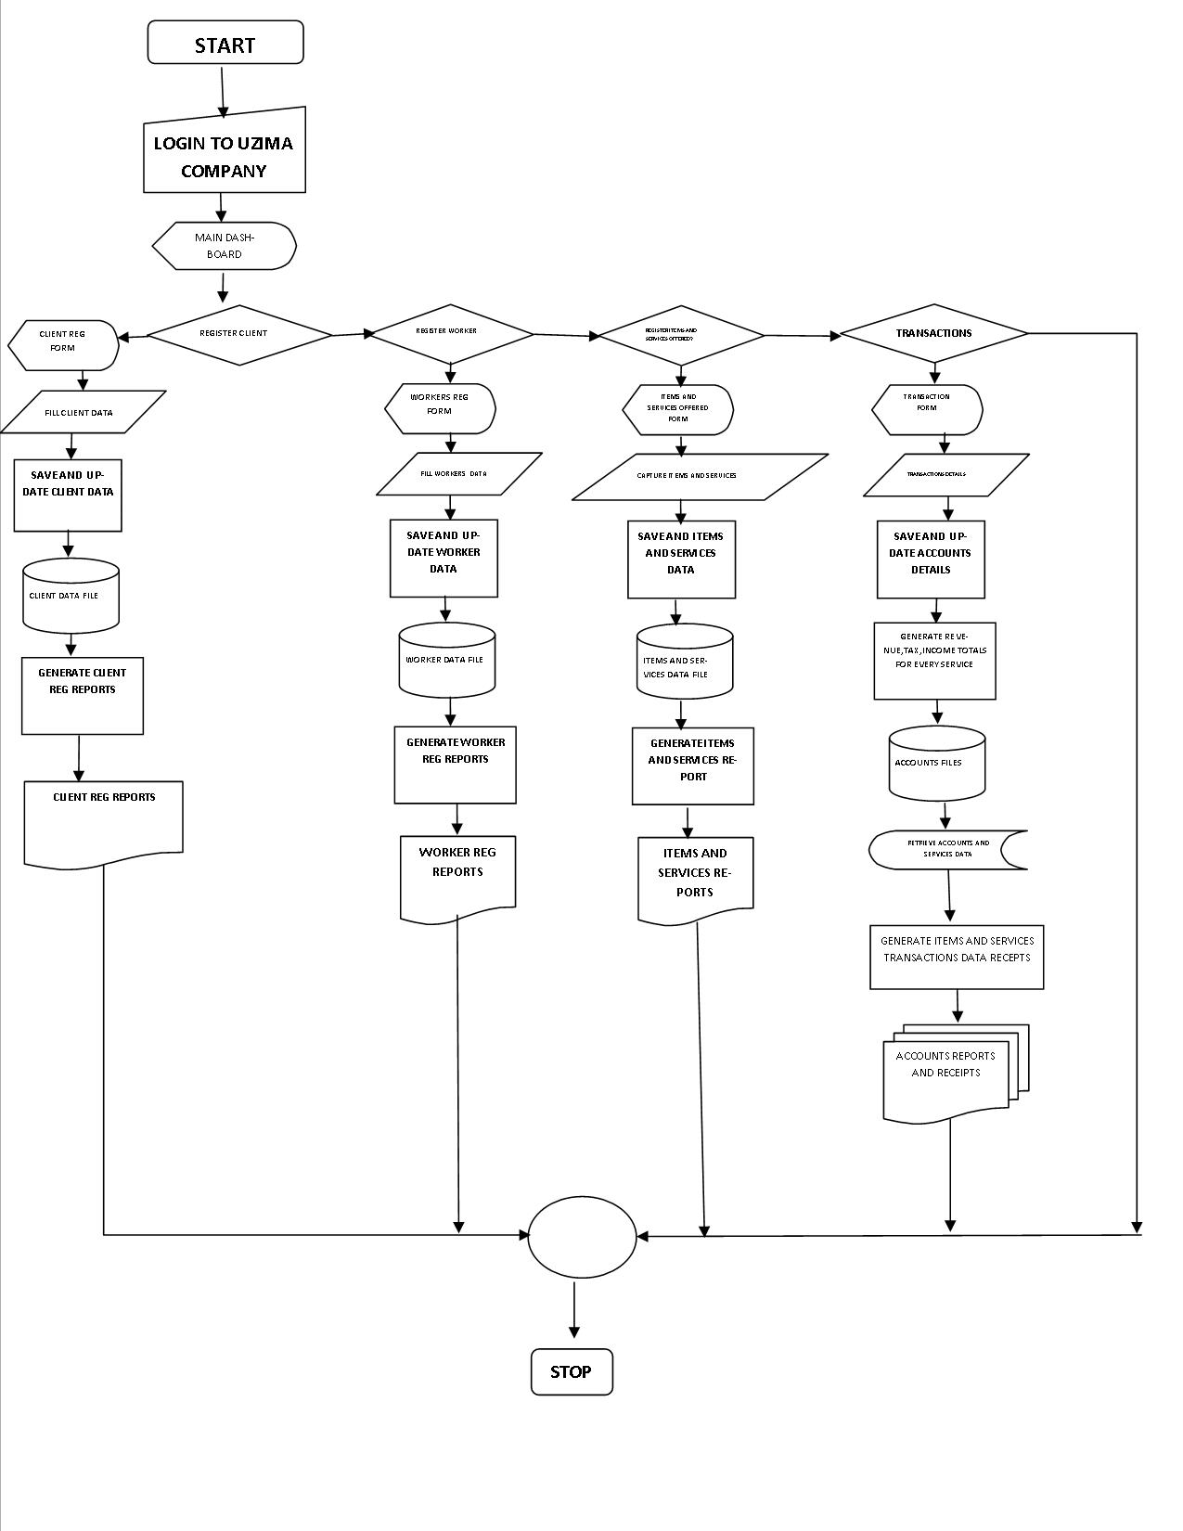

2.2 Table Design

TABLE NAME | FIELDS | DATA TYPE
CLIENTS | Customer ID | Autonumber
 | Client name | Short text
 | Type of client | Short text
 | Address | Short text
 | Telephone number | Number
 | Date of registration | Date /time
DRILLING SERVICES | Drilling ID | Autonumber
 | Type of drilling | Short text
 | Down payment | Currency
INSTALLATIONS | Customer ID | Number
 | Installations ID | Autonumber
 | Client name | Short text
 | Drilling type | Short text
 | Type of pump | Short text
 | Borehole depth | Number
 | Height of pump above sea level | Number
 | Number of pipes | Number
 | Pipe diameter | Number
 | Total number of tanks | Calculated
MAINTENACE | Maintenance ID | Auto number
 | Client name | Short text
 | Maintenance type | Short text
 | Number of repairs | Number
 | Repair cost | Currency
 | Total repair fee | Currency
 | Total labour fee | Currency
 | Tax paid | Currency
 | Total maintenance cost | Currency
OUTLETS | Outlets ID | Automunber
 | Client name | Short text
 | Type of outlet | Short text
 | Outlet size | Number
 | Number of outlets | Number
 | Price per outlet | Currency
 | Total price per outlet | Currency
PIPES | Pipe ID | Autonumber
 | Client ID | Number
 | Pipe type | Short text
 | Pipe diameter | Number
 | Running length | Number
 | Pipe cost | Currency
PLUMBING | Plumber ID | Autonumber
 | Client ID | Numbe r
 | Client name | Short text
PUMP DETAILS | Pump ID
 | Pump type
 | Pump installation cost
SERVICES | Service ID | Autonumber
 | Service type | Short text
TANK DETAILS | Tank ID | Autonumber
 | Tank capacity | Number
 | Tank price | Tank price

2.2.1 Entity relationship diagram

The tables used to depict the Entity relationship diagram for the Uzima Company computerized system include:
- Clients table
- Drilling services table
- Tanks details table
- Services table
- Pump details table
- Plumbing table
- Pipes table
- Outlets table
- Installations table
- Maintenance table
SURVEY AND LOCAL AUTHORITY FEES
Reg NO
The Entity Relationship Diagram is as illustrated below:
REGISTRATION
Reg No
CLIENTS
Reg NO

SERVICES
ServiceID

PUMP INSTALLATION
Reg No
WORKERS
Reg No
PLUMBING
Reg NO
ORDERS
Service ID

2.3 Input Design
Input design involves the manual pre-development of input forms for the respective data and records in Uzima Company Database Management Information System.
In this case , forms with user friendly data entry are used. Each table has a corresponding form for data input.
The specific form designs for the actual input screen are as shown:
UZIMA COMPANY
CLIENTS REGISTRATIONN FORM
CUSTOMER ID
CLIENTS NAME
TYPE OF CLIENT
SAVE
DELETE

ADDRESS

TELEPHONE NUMBER

DATE OF REGISTRATION

UZIMA COMPANY
DRILLING SERVICES FORM

DRILLING ID
TYPE OF DRILLING
DOWN PAYMENT

SAVE
DELETE

UZIMA COMPANY
SERVICES FORM

SERVICES ID
SERVICE NAME

SAVE
DELETE

SAVE
DELETE
UZIMA COMPANY
PLUMBING DEATILS FORM

CLIENT ID
PLUMBER ID
CLIENT NAME

SAVE
DELETE

UZIMA COMPANY
PIPES FORM
CLIENT ID
PIPE ID
TYPE OF PIPE
SAVE
DELETE

PIPE DIAMETER

RUNNING LENGTH

PIPE COST

UZIMA COMPANY
TANK DETAILS FORM

TANK ID
TANK CAPACITY
TANK PRICE

SAVE
DELETE

UZIMA COMPANY
OUTLETS FORM

OUTLET SIZE
OUTLET ID

NUMBER OF OUTLETS
CLIENTS NAME
PRICE PER OUTLET
TYPE OF OUTLET
TOTAL PRICE PER OULET

SAVE
DELETE

UZIMA COMPANY
CLIENTS REGISTRATIONN FORM
SAVE
DELETE
NUMBER OF REPAIRS
REPAIR COST
TOTAL REPAIR FEE
TOTAL LABOUR FEE

MAINTENANCE ID
CLIENTS NAME

MAINTENNCE TYPE

TAX PAID

UZIMA COMPANY
MAINTENANCE FORM
SAVE
DELETE
NUMBER OF REPAIRS
REPAIR COST
TOTAL REPAIR FEE
TOTAL LABOUR FEE

2.4 Output Design
This section outlines the most important aspect of an information system:The output .
In the Uzima Comapany , a number of output tools are used to achieve the operational demands for this system.
The output design tools used to achieve this include : Reports, Receipts,Invoice
The reports generated from the processing activities of the Uzima Company Information System Include:
- Tax paid
- Total amounts reports
- Registration fees report
- Total income report
- Plumbing reports

2.4.1 Registration Fees Report
UZIMA COMPANY
REGISTRATION FEES REPORT
Date
 | Reg No | Down Payment | Name | Date of Registration
 | Total Amount: KSh

2.4.2 Total Plumbing Fees Report
UZIMA COMPANY Date
PLUMBING FEES REPORT
 | Reg No | Pipe Type | Pipe Diameter | Plumbing Cost | Cost Of Pipe
 | TOTAL AMOUNT :KSH

2.4.3 Tax Payment Report
UZIMA COMPANY Date
TAX PAYMENT REPORT
Reg No | Service ID | Total Payment | Tax Payment
TOTAL TAX :KSH

2.4.4 Total Survey and Local Authority Fees Report
UZIMA COMPANY Date
SURVEY AND LOCAL AUTHORITY FEES REPORT
Reg No | Name | Local Authority Fees | Survey Fees
GRAND TOTAL :KSH

2.4.5 Revenue Generated Report
UZIMA COMPANY
REVENUE REPORT
Survey Fees | Local Authority Fees | Down Payment | Drilling Fees | Pump Fees
GRAND TOTAL:KSH

2.4.6 Items Sale And Service Provided Report
UZIMA COMPANY

ITEMS AND SERVICES REPORT

 | Item Name | Buying Price | Number In Stock | Service ID | Total Payment
 | TOTAL AMOUNT:KSH

2.4.7 Items Sold Receipt
UZIMA COMPANY

ITEM SOLD RECEIPT

SNO

 | Name | Quantity | Amount | Tax
NET AMOUNT:KSH.
Served By :Uzima Borehole Drilling company
Thank You For Choosing us

CHAPTER THREE

3.0 SYSTEM DEVELOPMENT
In this chapter, the overall development of this project from scratch to this working stage is fully documented. The required specifications have been fully met to come up with this running system of the Uzima Company Information System.
The system design phase has been fully furbished in order to come up with this chapter.
The database objects used during the Development of this Information System include:

3.1 TABLES
A number of tables have been used to come up with this fully working system.

3.1.1 CLIENTS TABLE
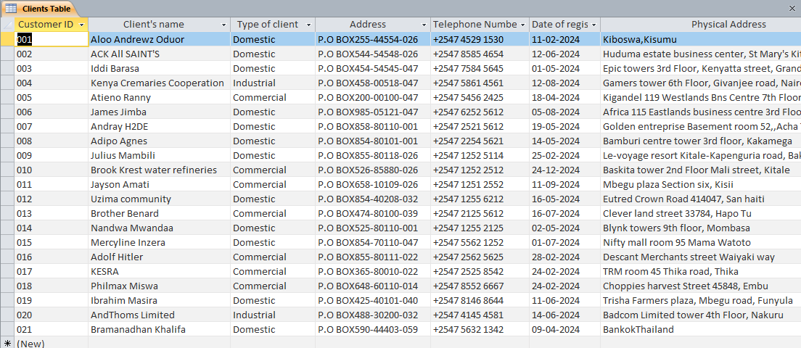
CLIENTS TABLE 1
This is the Clients Table. It contains the related fields meeting the system requirements for registering and keeping the necessary client data.

3.1.2 INSTALLATIONS TABLE
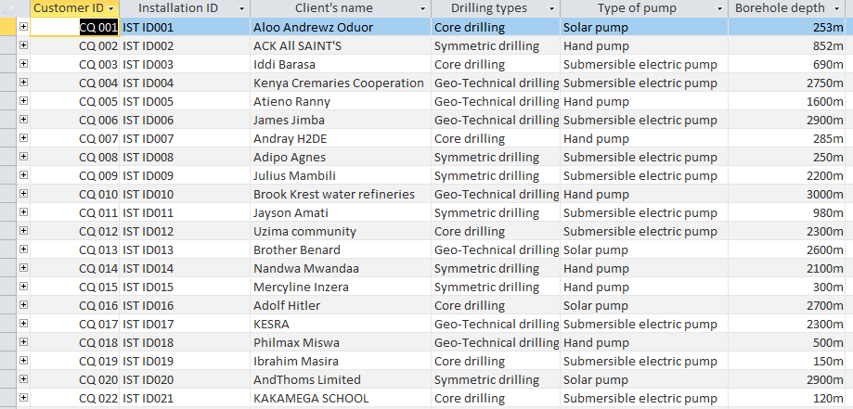
INSTALLATIONS Table 1
This table shows the Installations details captured during the actual process of installations. It provides a comprehensive detail of the data used to store installation details.

3.1.3 PLUMBING TABLE

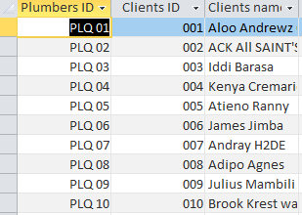
PLUMBING 1
This table show the plumbing details for the installation process.

3.1.4 PIPES TABLE
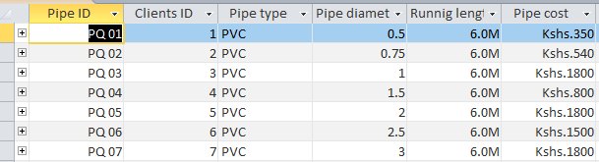
PIPES 1
The pipe details are captured by the system’s pipes table that are then stored in the database schema which are manipulated later in the calculations of total costs.

3.1.5 OUTLETS TABLE
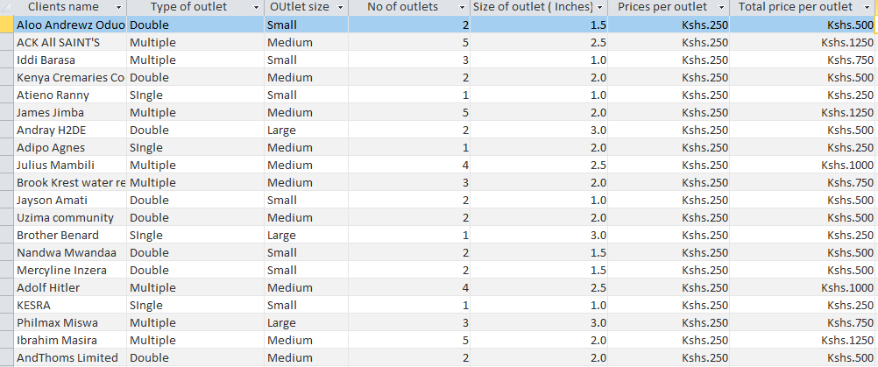
OUTLETS 1

3.1.6 DRILLING SERVICES TABLE
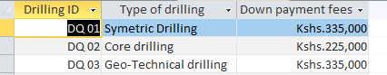
DRILLING SERVICES 1

3.2 FORMS
This section outlines the various types of form used in the data entry process for the Database system.
They include:

3.2.1 CLIENTS FORM
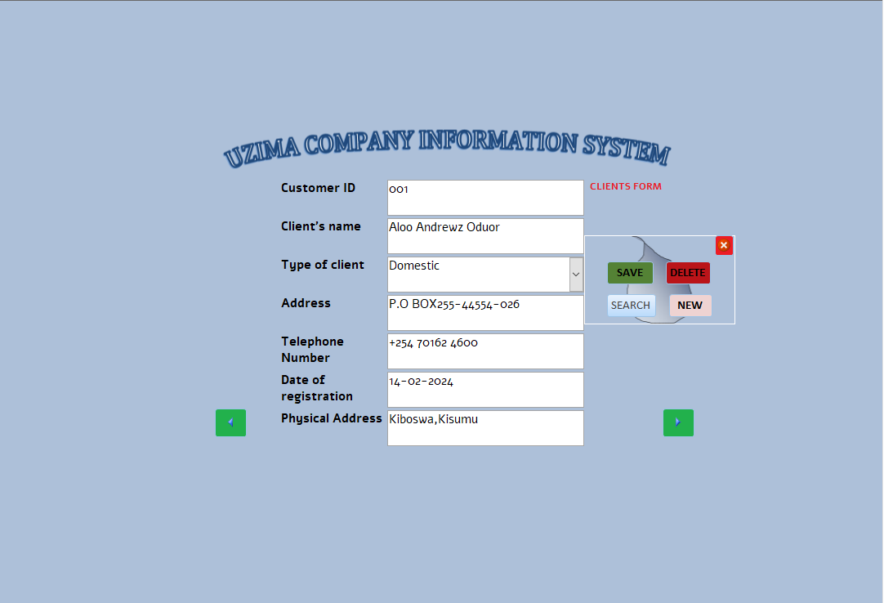
CLIENTS FORM 1

This form is for keying in the respective clients details into the Uzima Database system. The respective buttons are meant to navigate the interface with ultimate ease.

3.2.2 INSTALLATIONS FORM
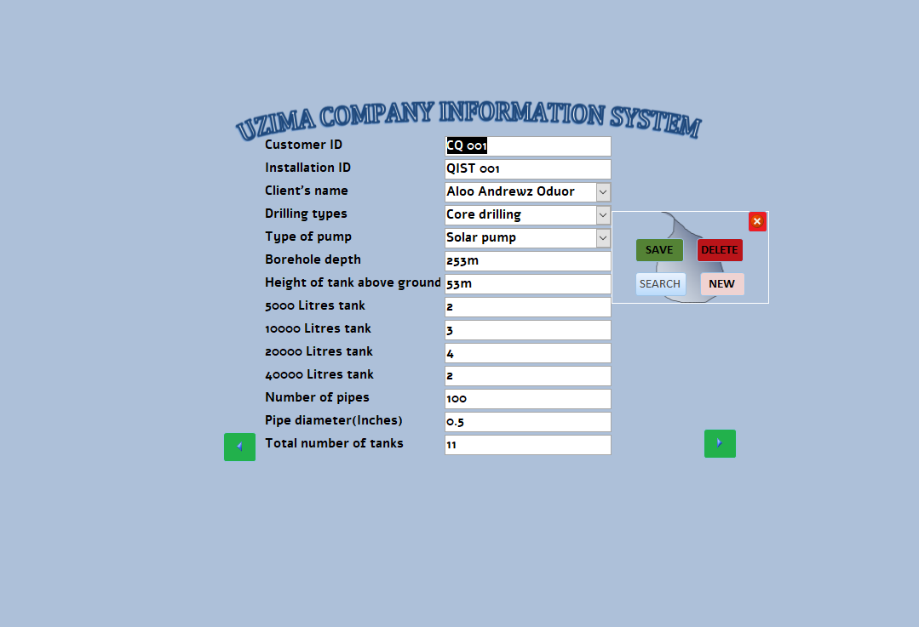
INSTALLATIONS FORM 1
All installation services are captured within the installations form and automatically updated to the installations table for processing.

3.2.3 DRILLING TABLE FORM
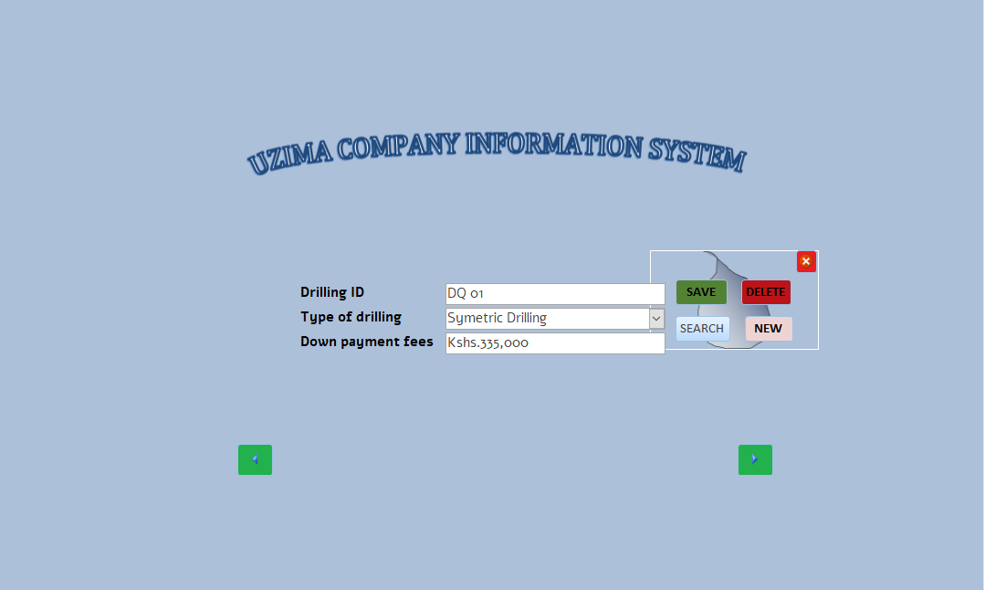
DRILLING SERVICES FORM 1
In case a client requires drilling services, the registered drilling services and their respective prices are recorded and captured within the drilling form.

3.2.4 PIPES TABLE FORM
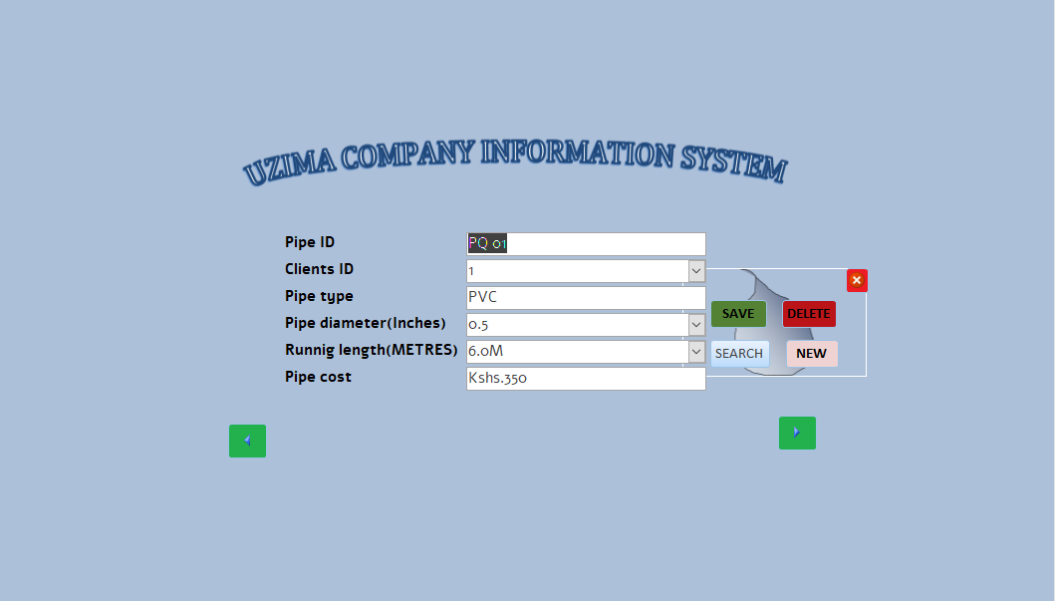
PIPES TABLE FORM 1
Pipes form accepts the pipes details a client is to buy and updates the pipes table for processing during calculation in respective queries.

3.2.5 OUTLETS TABLE FORM
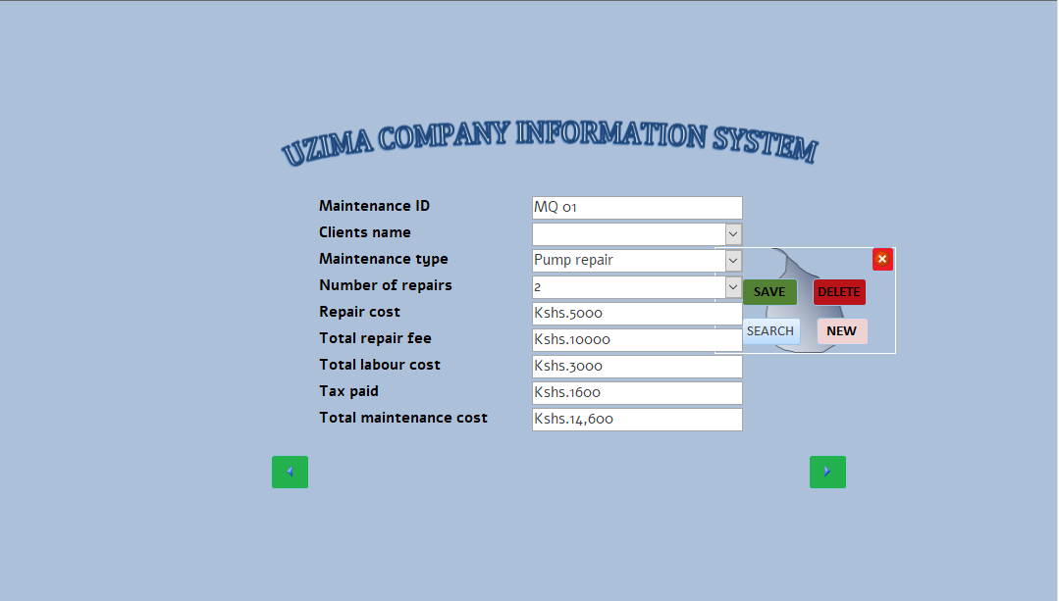
OUTLETS FORM 1
For every installations made, the outlets form is used to capture the outlets details that update the outets table thus providing the data that is adequately used in the Installations query.

3.3 QUERIES
In the Uzima Company, database queries have been used to manipulate the table data and provide the company with comprehensive outlay of the system’s functionality.
A number of queries have been used as listed below:
- Installations query
- Plumbing cost query
- Net income query
- Tax paid query
- Registrations query

3.3.1 INSTALLATION QUERY
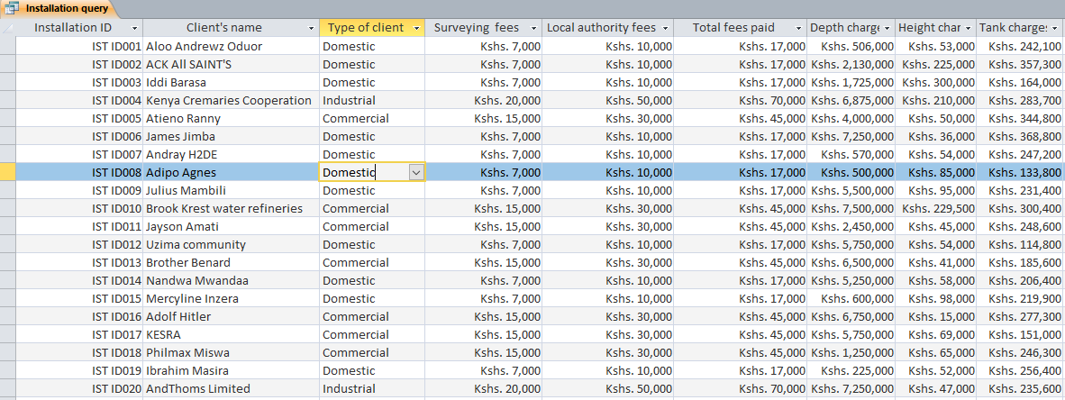
INSTALLATIONS QUERY 1
This query clearly outlines the resulting calculations of the installation charges that the Uzima Company Information system has captured over the working period.

3.3.2 PLUMBING COST QUERY
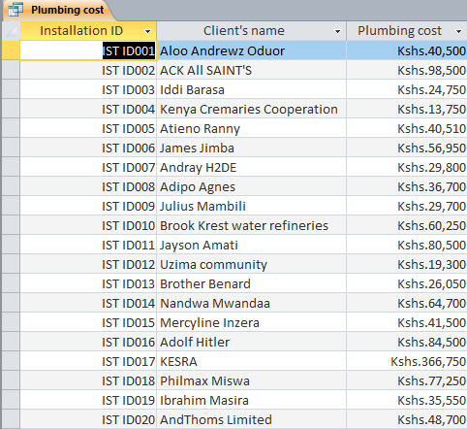
PLUMBING COST QUERY 1
Plumbing cost query is a criteria based query that brings out the comprehensive outlay of the plumbing cost against the clients’ name. providing the company with a comprehensive report on the plumbing cost charges made by the company.

3.3.3 NET INCOME QUERY
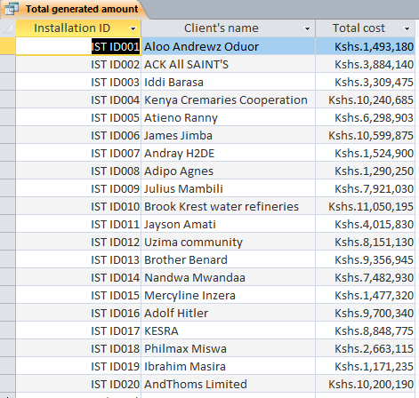
NET INCOME QUERY 1
Upon payment, the net income earned by the Uzima company is calculated by the Net income query.
The results is as shown above.

3.3.4 TAX PAID QUERY
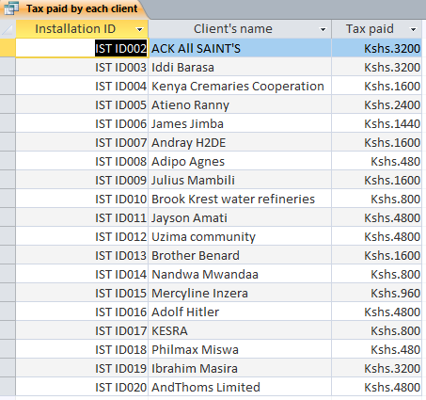
TAX PAID QUERY 1
The company charges a net tax of 0.16% of the total amount paid by the Client, this query is meant to generate the net tax the company has earned within the time stipulated.

3.3.4 REGISTRATION FEES QUERY
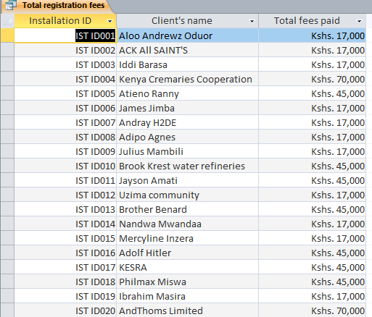
REGISTRATION FEES QUERY 1
Upon the client’s registration for the Uzima Company services, the client is to pay a registration fees as accustomed.
This query, retrieves the registration fees payable by the client and organizes it as one object.
.

3.4 REPORTS
This Uzima Company Information System ensures production of a comprehensive output for the organization at large to fathom what is necessarily in the system. Use of database reports is therefore necessitated for comprehensive understanding of this system.
The respective reports are as follows:

3.4.1 INSTALLATIONS REPORT
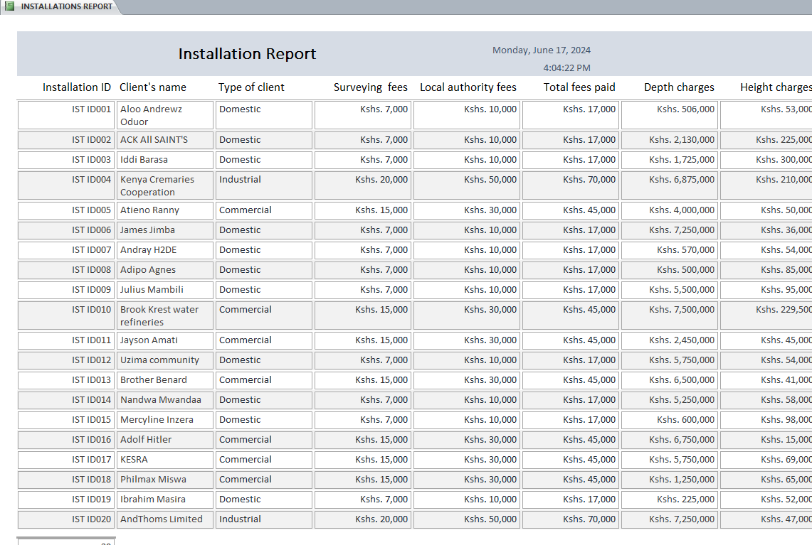
INSTALLATIONS REPORT 1
Generated from the installations query. It shows the summary of the installations made by the organization.

3.4.2 NET INCOME BY THE COMPANY REPORT
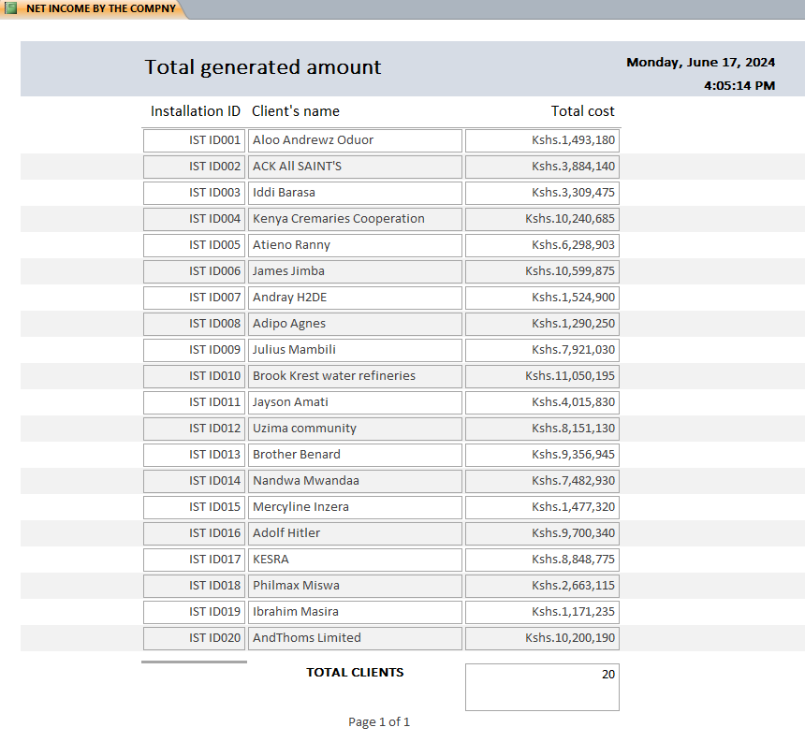
NET INCOME REPORT 1
Generated from the Net income query. It depicts the total income Uzima Company has earned over the working period.

3.4.3 TOTAL AMOUNT PAID BY EACH CLIENT
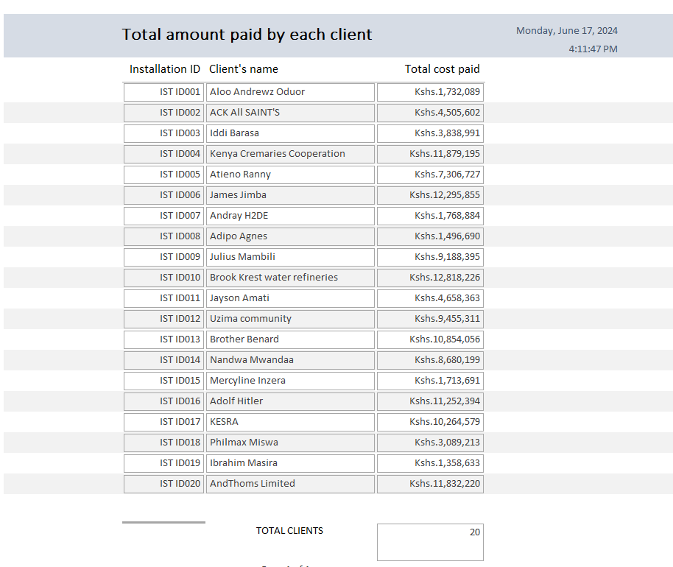
TOTAL AMOUNT PAID BY EACH CLIENT 1
The summary for the Total amount paid by the clients as generated by the respective query is summarized as above by the report.

3.4.4PLUMBING COST REPORT
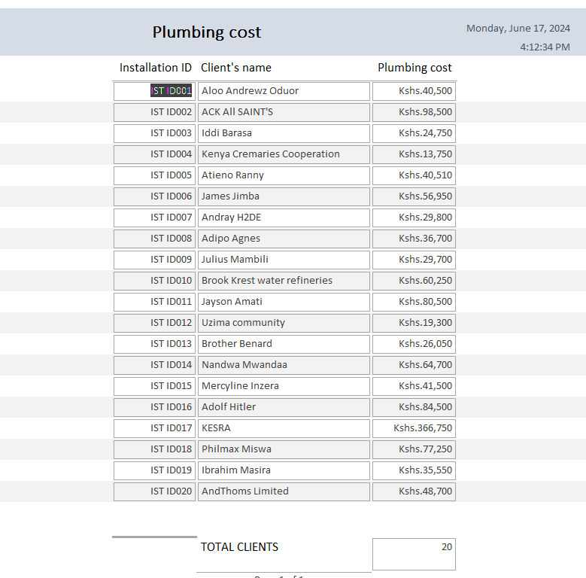
TOTAL PLUMBING COST 1
Plumbing cost report is used to clearly show the plumbing details, i.e the cost for the Uzima Company.

3.4.5 TAX PAID BY EACH CLIENT
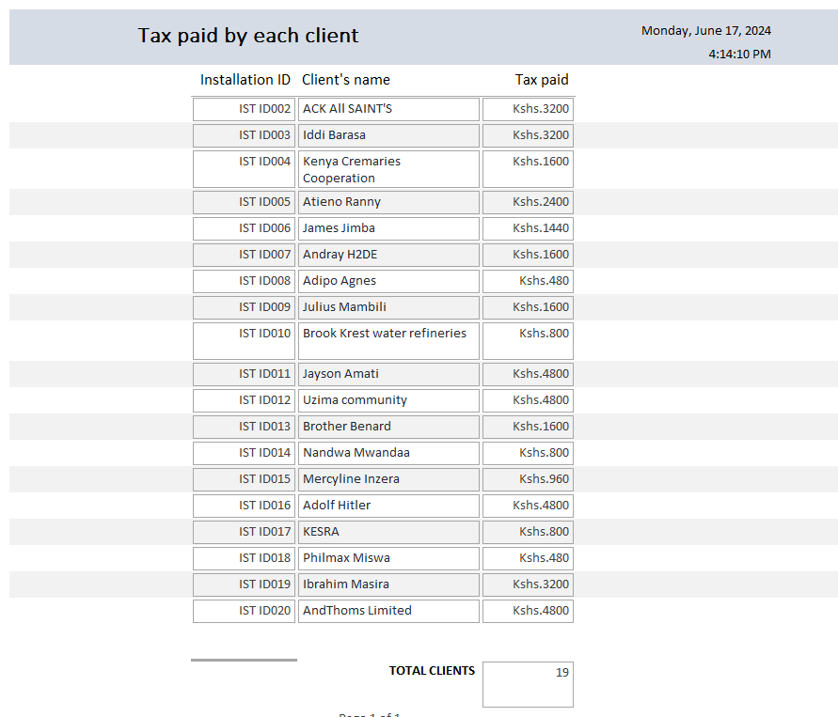
TOTAL TAX BY EACH CLIENT 1
Tax paid by each client has been summarized by this report. This is a product of the Tax paid query.

3.4.6 REGISTRATION FEES
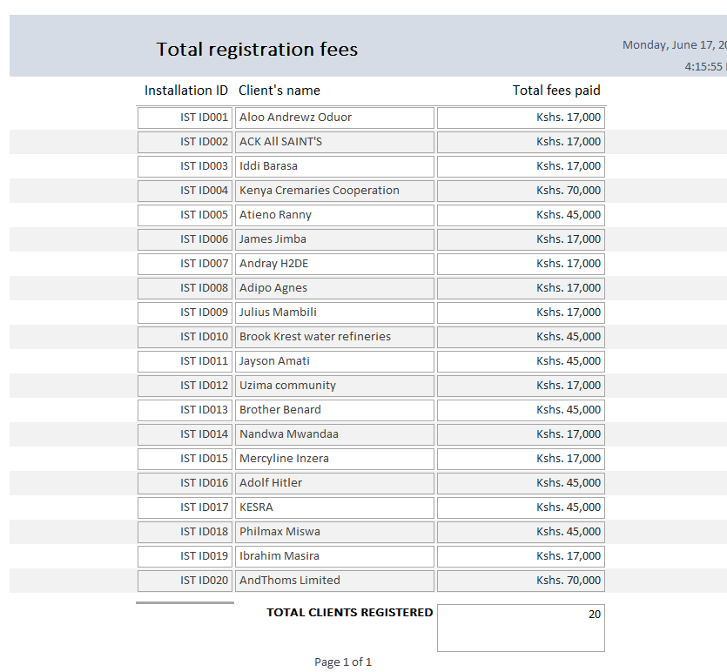
REGISTRATION FEES REPORT 1
Upon registration, the registration fees query is updated and the report is generated as shown above.

CHAPTER FOUR

4.0 Sytstem implementation
The Uzima Borehole drilling system once fully developed, is to be implemented through the following procedures:

4.1 Testing And debugging
This was conducted using the validation rules of the respective tables as shown below:
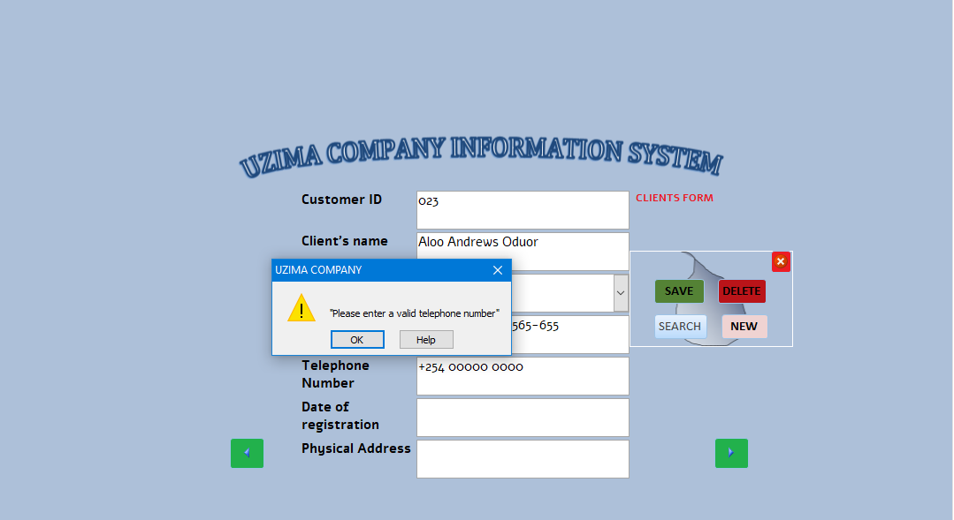
For this case, the validation rule was used to deny any telephone number not valid, for instance the client entered “00000000”

4.2 Installation and configuration

The installation of this system shall be done by the system developers. This should involve the installation of the desired soft wares such as Microsoft Access 2013.
The system is made portable through a portable HDD which should be installed on any customer service provider’s computer.

4.3 Training of staff

There shall be no need to newly train the new staff since the employment requirements should specify the computer literacy requirements.
Incase of an update, the staff should be well trained on the proper procedures of using the system to minimize on breakdown before entropy.

CHAPTER FIVE

5.0 USER MANUAL

5.1 Introduction
This section has been designed to enable user to freely and easily use this newly made Uzima Company Information System do achieve the earlier stated goals.
This computerized information system is meant to automate the data entry and capture process by providing the fundamental data entry tools at the convenience of the user for a more accurate and reliable task handling.

5.2 Installation and Requirements Guidelines
For this fully developed system to become efficiently operational, Uzima Borehole drilling Company needs to Purchase computers and appropriate hardware utilities to form a fully working environment for this Computerized Database system.
The company needs to fully invest in the Networked environment to ensure quick, secure and efficient running of the system.

5.3 Loading process
In this Computerized Uzima Company Information System, a number of loading procedures are dominant ;

- The user clicks the Uzima Company System Icon in the storage medium thus launching it.
- The database open password pops up. Enter the correct Database password, for this case is “37600001594” to open the database.
- In the Welcome screen that pops, click “OK”
- Enter the correct password and click “Enter the System”

The loading screen is as follows:
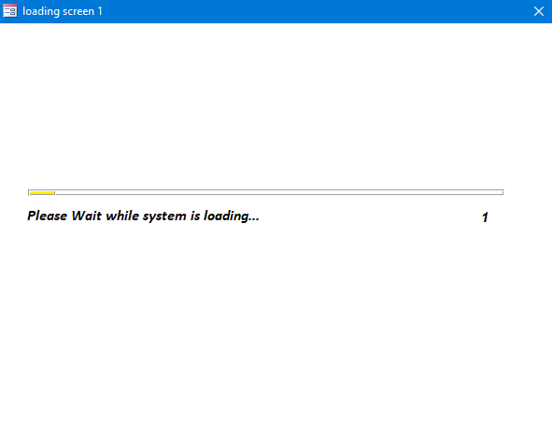
Remember: The first screen to appear is the welcome screen which Prompts the user to enter the system. The Login screen pops up to allow the user to key in the Login details thus accessing the system at large.
Data Entry
On the left pane is the Forms area. In this part, the user finds the navigation buttons for redirecting the user to the respective forms of desire.
At the right side are the generated reports of the resulting queries as discussed earlier.
Clicking the “CLOSE” button closes the Dashboard. The “EXIT SYSTEM” button exits the Uzima System and Stops any running program.

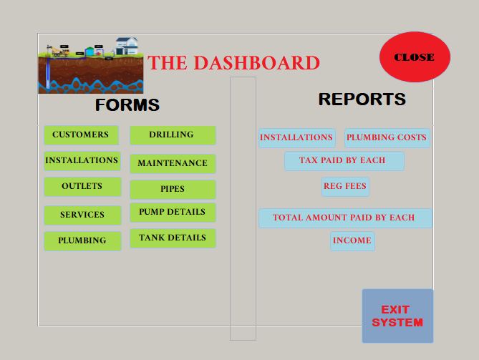
Security is ensured through the use of a password. This ensures only the authorized users can freely navigate through the system design and the data.
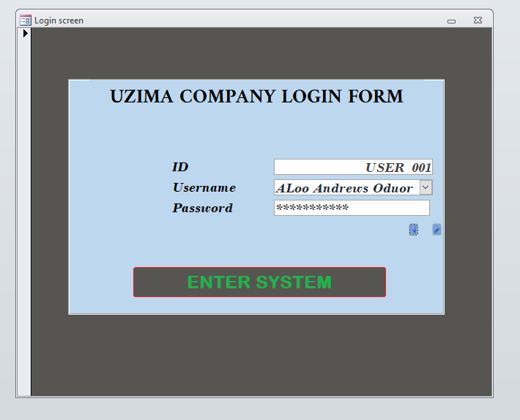
A dashboard is displayed, which automates navigation between forms and generated up to date reports which are easily accessed by a single click. The loading speed is relatively quick, but this will also highly depend on the Memory of computer under use.
The forms have navigation guides and action buttons that enable the user efficiently access this Uzima Information System with ease and more friendly.
The tables are automatically updated and reports generated upon data generation.
The reports generation procedure is an automated process. This is ensured by the use of Database queries that are run every time a report is executed, this ensures that provided data is entered, then the query generates the query output depending on the issued criteria.
The navigation guides are incorporated in any existing form. They include:
- Save
- Delete
- Next record
- Previous record
- Close
The navigation guide area is in the format shown below:
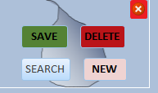


The loading process also include the navigation from entering the system to exit. This is easy-peasy as the navigation menu is made available to the user.

Troubleshooting guide
Invalid or erroneous data may lead to an error pop up on the screen. The common error is encountered if the user tries to enter an already registered data item, the system would alert the user on the same and give an alternative to sorting out the error.
Incase of violation of a rule, the various validation texts are displayed for the user to be aware of the error before proceeding.

CHAPTER 6

6.0 MISCELLANEOUS

6.1 Conclusion
In summary, by using this newly developed Uzima System, the user is enabled to prepare most of the documents that took a lot of time to process manually. In fact this is a more efficient and a stress free system that makes the user enjoy the working environment.
In order to remain competitive in the Borehole drilling industry in Kenya, Uzima is required to the advantage of benefits realized from use of ICT. This is the exact reason why this system came with brilliant ideas of computerizing the crucial business operations and processes. The intended goal has thus been achieved by coming up with this Computerized Uzima Company Information System.

6.2 Recommendation
I as the developer of this system therefore highly recommend that due the inadequate time allocated for the development of this Uzima Borehole Drilling System, this system be made more user friendlier by creating a mobile compatible user interface and availing the services online.
According the drawbacks stated earlier, this system should be adequately researched upon to alleviate the negative concerns that ,may hinder users of the Uzima Borehole Drilling Information System.

6.3 Bibliography
Mburu S and Chemwa G (2018):Lognhorn Secondary Computer Studies Form 3, Lognhorn publishers.
Mburu S and Chemwa G (2018):Lognhorn Secondary Computer Studies Form 4, Lognhorn publishers.
Mburu S and Chemwa G (2018):Lognhorn Secondary Computer Studies Form 2, Lognhorn publishers.

APPENDIX

